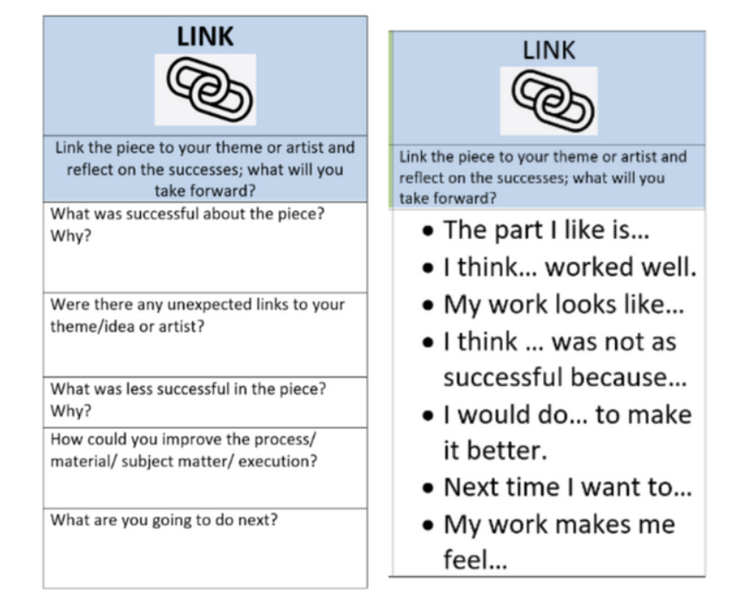

What was successful about this piece? Why?

Were there any unexpected links to your theme/idea or artist?

What was less successful in this piece? Why?

How could you improve the process?

